The new Seven Wonders

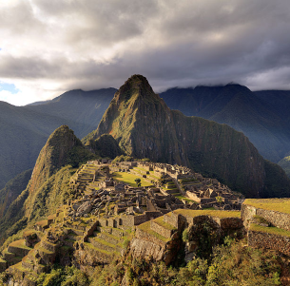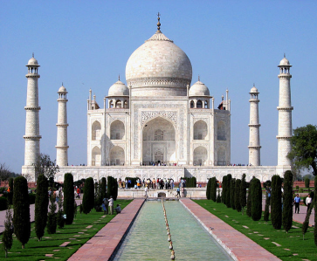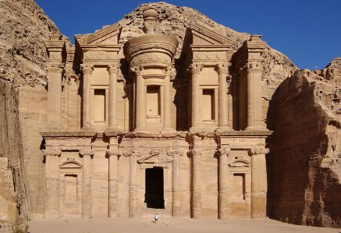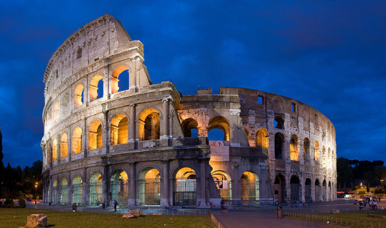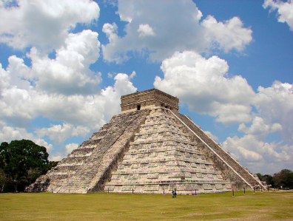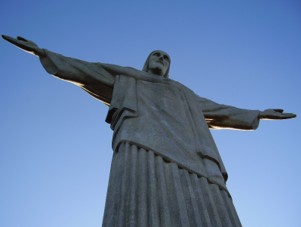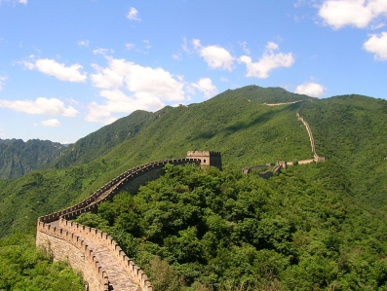of the World

**Chichen Itza**

The famous Mayan pyramids of Chichén-Itzá are over 1500 years old and are located only 75 miles from Mérida. The name Chichén-Itzá is a Mayan word: CHI (mouth) CHEN (well) and ITZA (of the Itza tribe). Some believe people were occasionally thrown into the nearby cenote as sacrifices, and those who survived were believed to be seers.

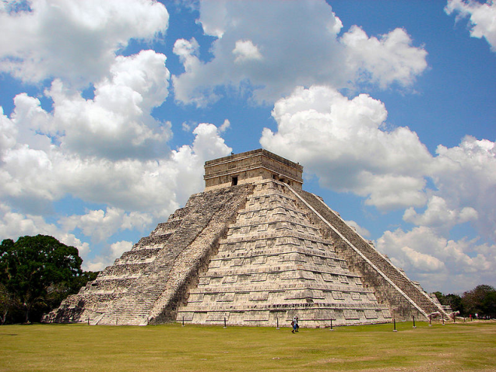

Figure 1: El Castillo (Pyramidd of Kukulcán) in Chichén Itzá

The main attraction is the central pyramid, also known as El Castillo, this spectacular, massive Mesoamerican step-pyramid that dominates the Chichen Itza archaeological site in the Mexican state of Yucatan. Today El Castillo is one of the most popular and recognized tourist sites of Mexico and as of 07/07/07, it is one of the Seven New Wonders of the World. Built by the Maya sometime between the 1000 and 1200 AD, El Castillo served as a temple to the god Kukulkan and is believed to have served as a calendar.

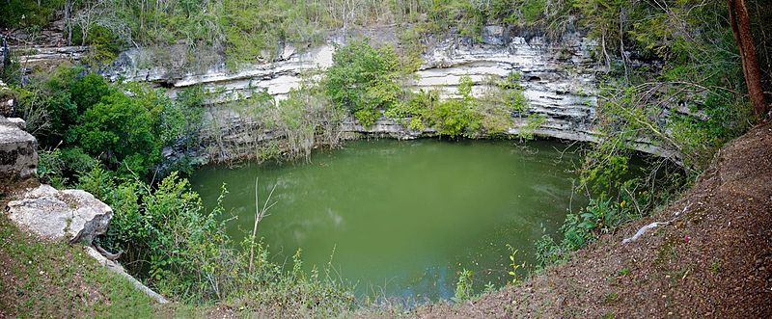

Figure 2: Cenote Sagrado

**Great Wall of China**

The Great Wall of China is a series of stone and earthen fortifications, built, rebuilt, and maintained between the 5th century BC and the 16th century to protect the northern borders of the Chinese Empire during the rule of successive dynasties. Several walls, referred to as the Great Wall of China, were built since the 5th century BC. The most famous is the wall built between 220 BC and 200 BC by the first Emperor of China, Qin Shi Huang; little of it remains; it was much farther north than the current wall, which was built during the Ming Dynasty. The Great Wall is the world's longest human-made structure, stretching over approximately 6,400 km (4,000 miles) from Shanhaiguan in the east to Lop Nur in the west, along an arc that roughly delineates the southern edge of Inner Mongolia, but stretches to over 6,700 km (4,160 miles) in total. It is also the largest human-made structure ever built in terms of surface area and mass. At its peak the Ming Wall was guarded by more than one million men. It has been estimated that somewhere in the range of 2 to 3 million Chinese died as part of the centuries-long project of building the wall.

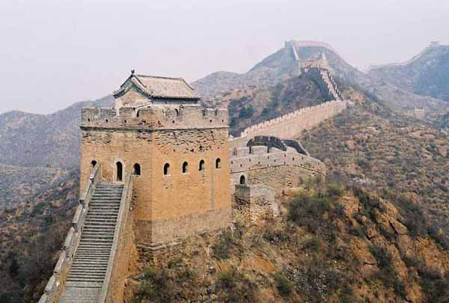

Figure 3: The great wall of China

The first major wall was built during the reign of the First Emperor, the main emperor of the short-lived Qin dynasty. This wall was not constructed as a single endeavor, but rather was created by the joining of several regional walls built by the Warring States. It was located much further north than the current Great Wall, and very little remains of it. A defensive wall on the northern border was built and maintained by several dynasties at different times in Chinese history. The Great Wall that can still be seen today was built during the Ming Dynasty, on a much larger scale and with longer lasting materials (solid stone used for the sides and the top of the Wall) than any wall that had been built before. The primary purpose of the wall was not to keep out people, who could scale the wall, but to insure that semi-nomadic people on the outside of the wall could not cross with their horses or return easily with stolen property.

**Statue of Christ the Redeemer**

The statue of Christ the Redeemer is located at the top of Corcovado Mountain. The entire monument of statue of Christ the Redeemer is 38m high with the statue accounting for 30m and overlooking the city of Rio de Janeiro is one of the tallest statues in the world; the span from finger tip to fingertip is 28m and there is a small chapel housed in the base.

The reason why it was built was to show that Christ loves all. In Portuguese, this iconic monument is known as Cristo Redentor. Christ the Redeemer was designed by a French sculptor by the name of Paul Landowski and a local engineer named Heitor da Silva Costa was chosen to supervise the entire construction. The statue was built not out of steel but from reinforced concrete as that was considered a more suitable material for the cross shaped statue. The external caps of the idol were constructed in soapstone due to the resistance of this material to the extreme time and also due to its malleability.

The statue of Christ the Redeemer can be accessed by the 2.4 meter Corcovado Railway that has the capacity to hold 360 passengers every hour. The trip by rail is approximately 20 minutes and leaves the base each half hour. From the road or the train terminal Christ the Redeemer statue is reached by 222 steps. For those not wishing to make the arduous trek up the mountain, reaching the statue is possible by escalators and elevators.

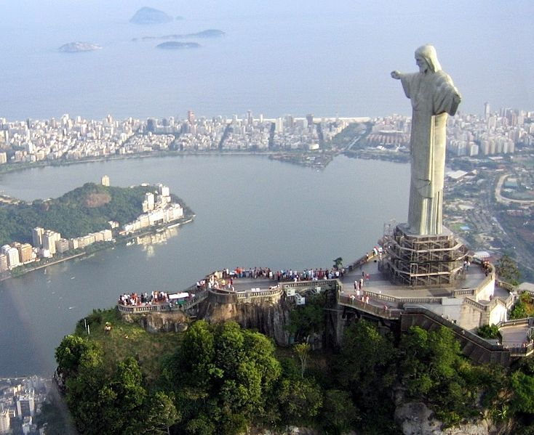

Figure 4: A view of the statue, as seen from a helicopter.

**Colosseum**

The Colosseum, or the Coliseum, originally the Flavian Amphitheatre (Latin: Amphitheatrum Flavium, Italian Anfiteatro Flavio or Colosseo), is an elliptical amphitheatre in the centre of the city of Rome, Italy, the largest ever built in the Roman Empire. It is considered one of the greatest works of Roman architecture and Roman engineering.

Occupying a site just east of the Roman Forum, its construction started in 72 AD under the emperor Vespasian and was completed in 80 AD under Titus, with further modifications being made during Domitian's reign (81–96). The name "Amphitheatrum Flavium" derives from both Vespasian's and Titus's family name (Flavius, from the gens Flavia).

Capable of seating 50,000 spectators, the Colosseum was used for gladiatorial contests and public spectacles such as mock sea battles, animal hunts, executions, re-enactments of famous battles, and dramas based on Classical mythology. The building ceased to be used for entertainment in the early medieval era. It was later reused for such purposes as housing, workshops, quarters for a religious order, a fortress, a quarry, and a Christian shrine.

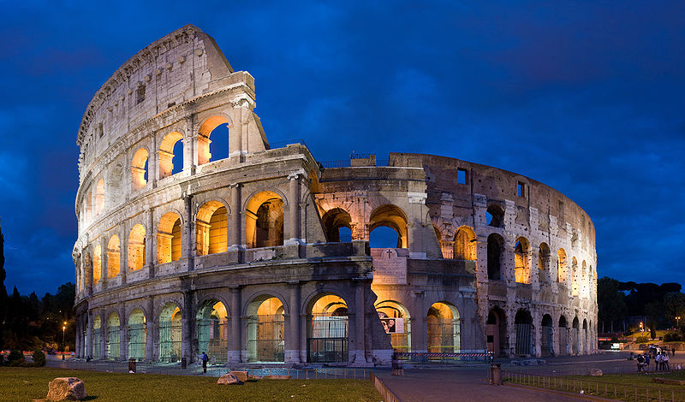

Figure 5: The exterior of the Colosseum

Although in the 21st century it stays partially ruined because of damage caused by devastating earthquakes and stone-robbers, the Colosseum is an iconic symbol of Imperial Rome. It is one of Rome's most popular tourist attractions and still has close connections with the Roman Catholic Church, as each Good Friday the Pope leads a torchlit "Way of the Cross" procession that starts in the area around the Colosseum.

**Petra**

Petra (Greek "πέτρα" (petra), meaning rock) is a historical and archaeological city in the Jordanian governorate of Ma'an that is famous for its rock cut architecture and water conduits system. Established sometime around the 6th century BC as the capital city of the Nabataeans, it is a symbol of Jordan as well as its most visited tourist attraction. It lies on the slope of Mount Hor in a basin among the mountains which form the eastern flank of Arabah (Wadi Araba), the large valley running from the Dead Sea to the Gulf of Aqaba. Petra has been a UNESCO World Heritage Site since 1985.

1. 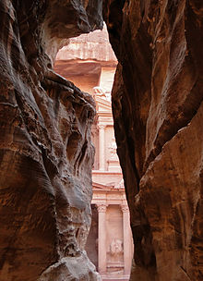 b. 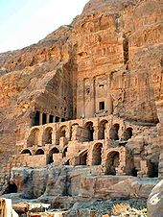

Figure 6: a) The end of the Siq, with its dramatic view of Al Khazneh ("The Treasury") b) Urn Tomb

The site remained unknown to the Western world until 1812, when it was introduced by Swiss explorer Johann Ludwig Burckhardt. It was described as "a rose-red city half as old as time" in a Newdigate Prize-winning poem by John William Burgon. UNESCO has described it as "one of the most precious cultural properties of man's cultural heritage". Petra was chosen by the BBC as one of "the 40 places you have to see before you die".

Petra was also the site for Indiana Jones, The Last Crusade. The Siq is in the film called "The Canyon of The Crescent Moon". Petra's ruins became world widely known and more famous because of the film.

**Taj Mahal**

Taj Mahal is regarded as one of the eight wonders of the world, and some Western historians have noted that its architectural beauty has never been surpassed. The Taj is the most beautiful monument built by the Mughals, the Muslim rulers of India. Taj Mahal is built entirely of white marble. Its stunning architectural beauty is beyond adequate description, particularly at dawn and sunset. The Taj seems to glow in the light of the full moon. On a foggy morning, the visitors experience the Taj as if suspended when viewed from across the Jamuna river.

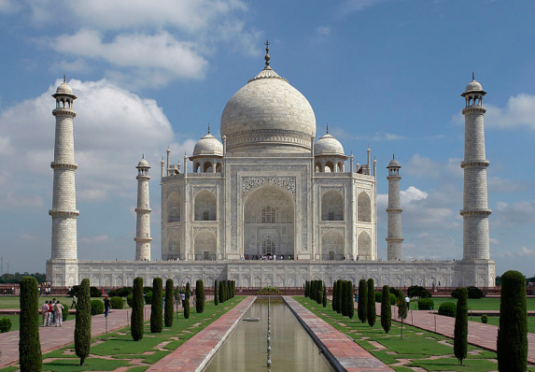Taj Mahal was built by a Muslim, Emperor Shah Jahan (died 1666 C.E.) in the memory of his dear wife and queen Mumtaz Mahal at Agra, India. It is an "elegy in marble" or some say an expression of a "dream." Taj Mahal (meaning Crown Palace) is a Mausoleum that houses the grave of queen Mumtaz Mahal at the lower chamber. The grave of Shah Jahan was added to it later. The queen’s real name was Arjumand Banu. In the tradition of the Mughals, important ladies of the royal family were given another name at their marriage or at some other significant event in their lives, and that new name was commonly used by the public. Shah Jahan's real name was Shahab-ud-din, and he was known as Prince Khurram before ascending to the throne in 1628.

Figure 7: Southern view of the Taj Mahal

Taj Mahal was constructed over a period of twenty-two years, employing twenty thousand workers. It was completed in 1648 C.E. at a cost of 32 Million Rupees. The construction documents show that its master architect was Ustad ‘Isa, the renowned Islamic architect of his time. Expert craftsmen from Delhi, Qannauj, Lahore, and Multan were employed. In addition, many renowned Muslim craftsmen from Baghdad, Shiraz and Bukhara worked on many specialized tasks.

The mausoleum is a part of a vast complex comprising of a main gateway, an elaborate garden, a mosque (to the left), a guest house (to the right), and several other palatial buildings. The large garden contains four reflecting pools dividing it at the center. Each of these four sections is further subdivided into four sections and then each into yet another four sections. Like the Taj, the garden elements serve like Arabesque, standing on their own and also constituting the whole.

**Machu Picchu**

Machu Picchu ("Old Peak") is a pre-Columbian 15th-century Inca site located 2,430 metres (7,970 ft) above sea level. It is situated on a mountain ridge above the Urubamba Valley in Peru, which is 80 kilometres northwest of Cusco and through which the Urubamba River flows. Most archaeologists believe that Machu Picchu was built as an estate for the Inca emperor Pachacuti (1438–1472). Often referred to as the "Lost City of the Incas", it is perhaps the most familiar icon of the Inca World.

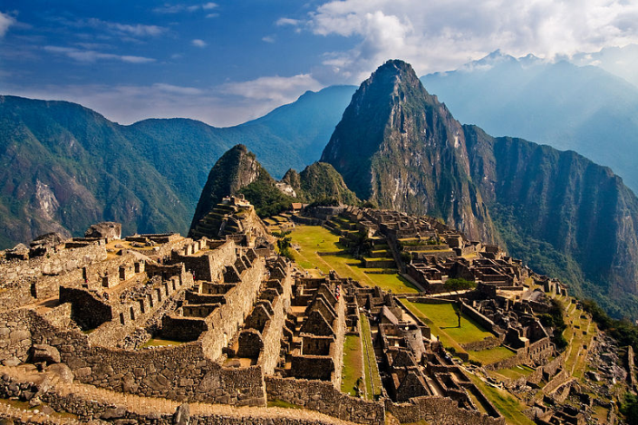The Incas started building the "estate" around AD 1400, but abandoned it as an official site for the Inca rulers a century later at the time of the Spanish Conquest. Although known locally, it was unknown to the outside world before being brought to international attention in 1911 by the American historian Hiram Bingham. Since then, Machu Picchu has become an important tourist attraction. Most of the outlying buildings have been reconstructed in order to give tourists a better idea of what the structures originally looked like. By 1976, thirty percent of Machu Picchu had been restored. The restoration work continues to this day.

Figure 8: A complete overview of the site

Since the site was never known to the Spanish during their conquest, it is highly significant as a relatively intact cultural site. Machu Picchu was declared a Peruvian Historical Sanctuary in 1981 and a UNESCO World Heritage Site in 1983. In 2007, Machu Picchu was voted one of the New Seven Wonders of the World in a worldwide Internet poll.

Machu Picchu was built in the classical Inca style, with polished dry-stone walls. Its three primary buildings are the Intihuatana, the Temple of the Sun, and the Room of the Three Windows. These are located in what is known by archaeologists as the Sacred District of Machu Picchu. In September 2007, Peru and Yale University almost reached an agreement regarding the return of artifacts which Yale has held since Hiram Bingham removed them from Machu Picchu in the early 20th century. In November 2010, a Yale University representative agreed to return the artifacts to a Peruvian university.